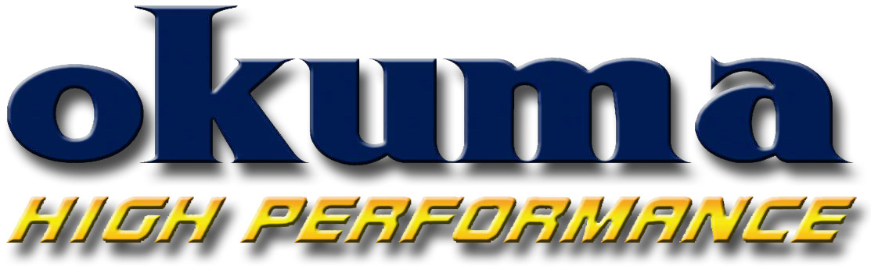
Okuma Fishing Tackle
2310 E. Locust Court
Ontario, CA 91761

Phone: (909) 923-2828
FAX: (909) 923-2909
www.okumafishing.com

For Immediate Release

DATE: 7/1/2010

Contact: Brandon Cotton
(909) 923-2828 Ext. 111
E-mail: brandon.cotton@okumafishing.com

Andros 5-Size 2-Speed Lever Drags

ONTARIO, Calif. - Packing incredible strength and power into its’ minimalist frame and body size, the all-new two-speed Okuma Andros is poised to electrify saltwater anglers targeting big game with ever-smaller equipment. Immediately noticeable is the Andros machined aluminum frame, side plates and spool. Upon closer inspection, it becomes very clear Andros construction doesn’t waste a bit of space. Spool capacity is maximized with very tight tolerances and only a minimum of frame rise over the spool. The external adjustable cast control system is tied directly to the drag system, eliminating space for the housing of additional systems. The right side plate is taken down with a single screw for fast, easy internal access.
On the interior, Andros construction pulls from the strength of Okuma’s Makaira and Cedros lever drag series: 6 ABEC-5 rated EZO Japanese ball bearings, 17-4 grade stainless steel helical cut gears, wet Carbonite drag system with Cal’s drag grease and ratcheting drag lever for precise drag settings. The gear system delivers ratios of 6.4:1 in high and 3.8:1 in low. Anglers connect with Andros inherent power through Okuma’s Ergo Grip handle and anodized aluminum handle arm.
The Andros’ drag system delivers a maximum of 15lbs. of drag at Strike with complete freespool, and continues to 24lbs. at Full while maintaining complete freespool. Comfort and control over Andros’ inherent power is maximized with an integrated recessed reel foot design for a low-profile fit on rods.
Set ablaze with a striking combination of deep charcoal and burnt orange anodizing, Andros delivers both the performance and cosmetic advances top anglers respect and demand.

